E-Clothes - Full Stack Web Application Report
Student Name: Rahul Pohwani
Student ID: x21482326
Introduction
The E-Clothes project is my full-stack web application developed as part of my cloud Application. The main purpose of this project was to design and make and, build, and deploy a working E-Commerce platform developed web development methods to make the application. The application allows users to view clothing products, create an account, log in which is secure, and you will be able to manage your shopping cart

In today's digital world, e-commerce platforms will play a big role in connecting customers with products efficiently and from this the store will be able to make sales . This project aims to simulate a simplified version of such a platform while focusing on clean design, usability, and correct implementation of backend logic and the data is saved on sql lite database

The project shows and displays a clear separation between frontend and backend parts in the project, use of a database for consistent storage, and deployment to a cloud environment which is called AWS . Throughout development and making, emphasis was placed on writing understandable code, following good structure, and meeting the functional and non-functional requirements of the assignment. And I made sure the website was fully working and you can sell and buy products
Project Background and Objectives
The motivation behind developing E-Clothes was to gain experience and work and building a real-world web application from scratch. Rather than focusing on advanced or unnecessary features, the project was designed to make an ecommerce website that allows customers to buy products online and get them delivered to their home and this website displays information about the products that will be sold on the website

The primary objectives of the project were:
To design a user-friendly frontend interface
To implement backend logic for authentication and data handling
To store and retrieve data using a relational database such as SQL lite
To deploy the application to a cloud platform such as AWS
To test the application to ensure reliability and correctness of the website

By achieving these objectives, the project demonstrates a complete development lifecycle, from initial design to final deployment.
User Requirements and System Features
The system was designed with two main user groups in mind: general users and administrators and . General users interact with the system through the frontend interface, while administrative tasks such as managing product data are handled internally.

Functional requirements include user registration, user login, browing products you like, managing cart , and secure session handling. Non-functional requirements include ease of use, responsive website , maintainability, and basic security protocols to protect user data

The system ensures that users can only be allowed to see some features , such as the cart, once they are verified and they are allowed in. This improves security and shows us real-world application behavior.
GitHub Repository and Video Demonstration
The complete source code for the E-Clothes project is hosted on GitHub at https://github.com/rahul1862.
The repository includes backend code, frontend templates, database configuration, and supporting files.

A short video demonstration was also created to showcase the deployed application. The shows us the main features , including product browsing, user login, sign-up, and cart functionality. This shows us uses the that the website is deployed on the AWS cloud and it is selling products and the website is allowing full use of the website made and deployed
https://github.com/rahul1862 it is available here
Backend Design and Implementation
The backend of the E-Clothes application was implemented using the Flask web framework with an SQLite database. Flask was chosen due to its lightweight nature and ease of integration with frontend webserver and was able to host the website

The backend is responsible for handling all server logic, including processing user requests, validating and accepting input data, managing authentication data and users, and interacting with they database which was made in sql lite. Routes were made for login, registration, product listing, and cart operations.

A simple and clear structure was used to separate routes, models, and functions in the web application . This improves ability to read and makes future updates easier. Input validation was put into the application to stop invalid or incomplete data from being stored in the database on SQLite.
Database Design
The application uses an SQLite relational database to store and use and access data. The database uses and I have added tables for users, products, and cart items. Each table was designed to store only important information while maintaining clear relationships between entities and the user and the web application.

User passwords are stored securely using hashing methods instead of plain text. This approach improves security and in my opinion uses good development practices. Foreign key relationships ensure that cart items are linked to the right user accounts.
Frontend Design and User Interface
The frontend of E-Clothes was designed to be made simple and easy to use by the user as the main priorities. The interface uses a consistent layout, clear navigation links, and readable fonts to ensure a positive user experience and the products and logo are show at the front so it can be easy to use by the user

The home page shows available products in and I put it in a structured layout, including images and prices, and availability status of the products . Users can easily see the products that are in stock and add them to their cart and then be able to purchase them when they can go to the cart menu

The login and sign-up pages use simple forms with clear labels, making them easy to understand even for first-time users.
Figure 1: E-Clothes Home Page

Figure 2: User Login Page

Figure 3: User Sign-Up Page

Additional Functionality
Other than basic browsing, the application shows us shopping cart Part of my application. Users can add products to their cart and are able to view selected items before checkout. Session handling ensures that cart data stays linked to the logged-in user.

Stock availability checks stops users from putting in out-of-stock items, improving the system by being reliable and easy use of the system.

Testing Strategy One of the key components of the development procedure was the testing component, and this was carried out throughout the project life.
manual testing was mainly carried out with time constraint and also extent of project with major focus on the core functions and the user flows.
Functional testing ensured that all the key features were performing as per expectation. To check user registration, new accounts were created and it was made possible to test the log-in with valid and invalid credentials to verify the authentication functionality and also to test the error situation.
There was also the test of the functionality of the cart that involved adding products, viewing the content of the cart and making sure that the cart information was linked correctly with the signed-in user.
Additional tests ensured that individuals could not add out of stock items besides the fact that the state of availability was indicated appropriately on the front in the right sense.
All the forms were signed in and infected with input validation testing to ensure that blank fields, inappropriate passwords and erroneous entries are handled.
This reduced impacts of collision and made it more reliable.
Simple usability test was also done, that is, usage of the application as a final user to ensure that page transition and behaviour remain smooth.
Despite the few automated tests, this manual testing plan came in handy in detecting and fixing the common issues at the development stage. Implementation of Kubernetes and AWS. E-Clothes application has been deployed with the help of AWS Elastic Beanstalk. Application deployment on the cloud enables returning to a real-world production environment and provides the ability to access the application anywhere.
Environment variables and configuration setting were also modified during the deployment to make the application functional outside the local deployment. During the debugging, any deployment problems that had occurred were solved by testing.
Challenges and Limitations The deployment configuration of my web application was one of the challenges which occurred during the project. Due to the critical issues with the apps operating in the cloud, specific attention was paid to debugging the applications and making sure that they would behave identically in the cloud and locally.
The other issue that I had during my project was time that did not allow me to use complex features of my project like payment method or automated testing. Act Victory and Future Enhancements.
The E-Clothes project is a good demonstration of a fully developed web application being created.
It offered great experience in frontend design and backend development, database integration and testing, and cloud deployment.
In the event that the project is developed further in the future, potential enhancement areas consist of the addition of payment methods wherein payments can be made, better automated testing coverage, and improvement of the user system web application. Altogether, the project achieves its goals and represents a good knowledge of the web development techniques and principles applied.
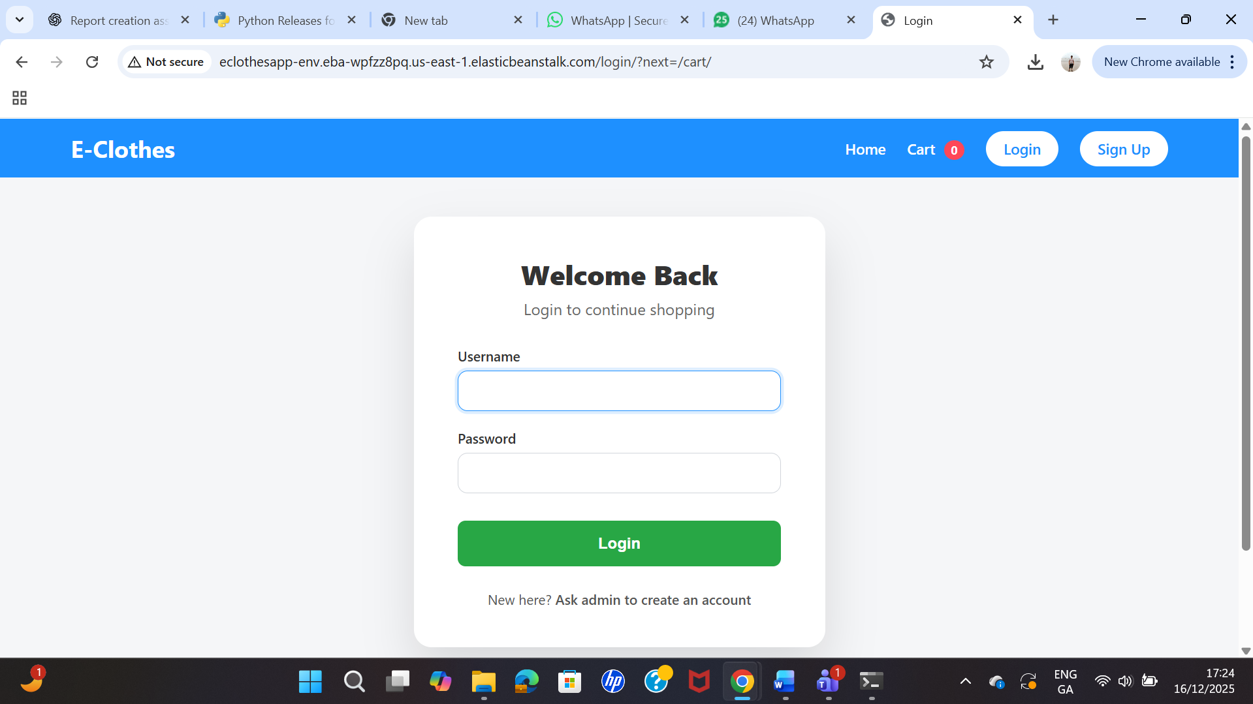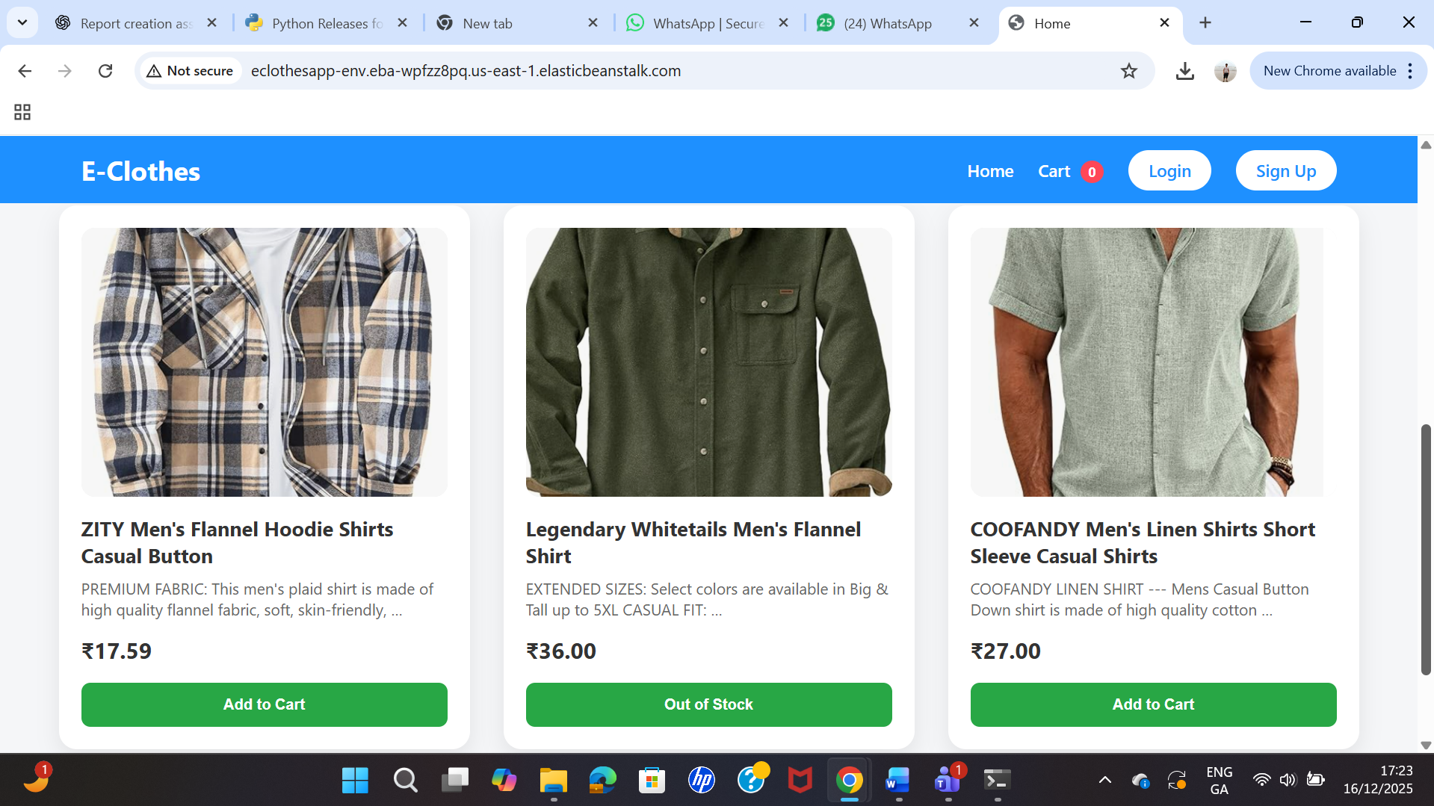
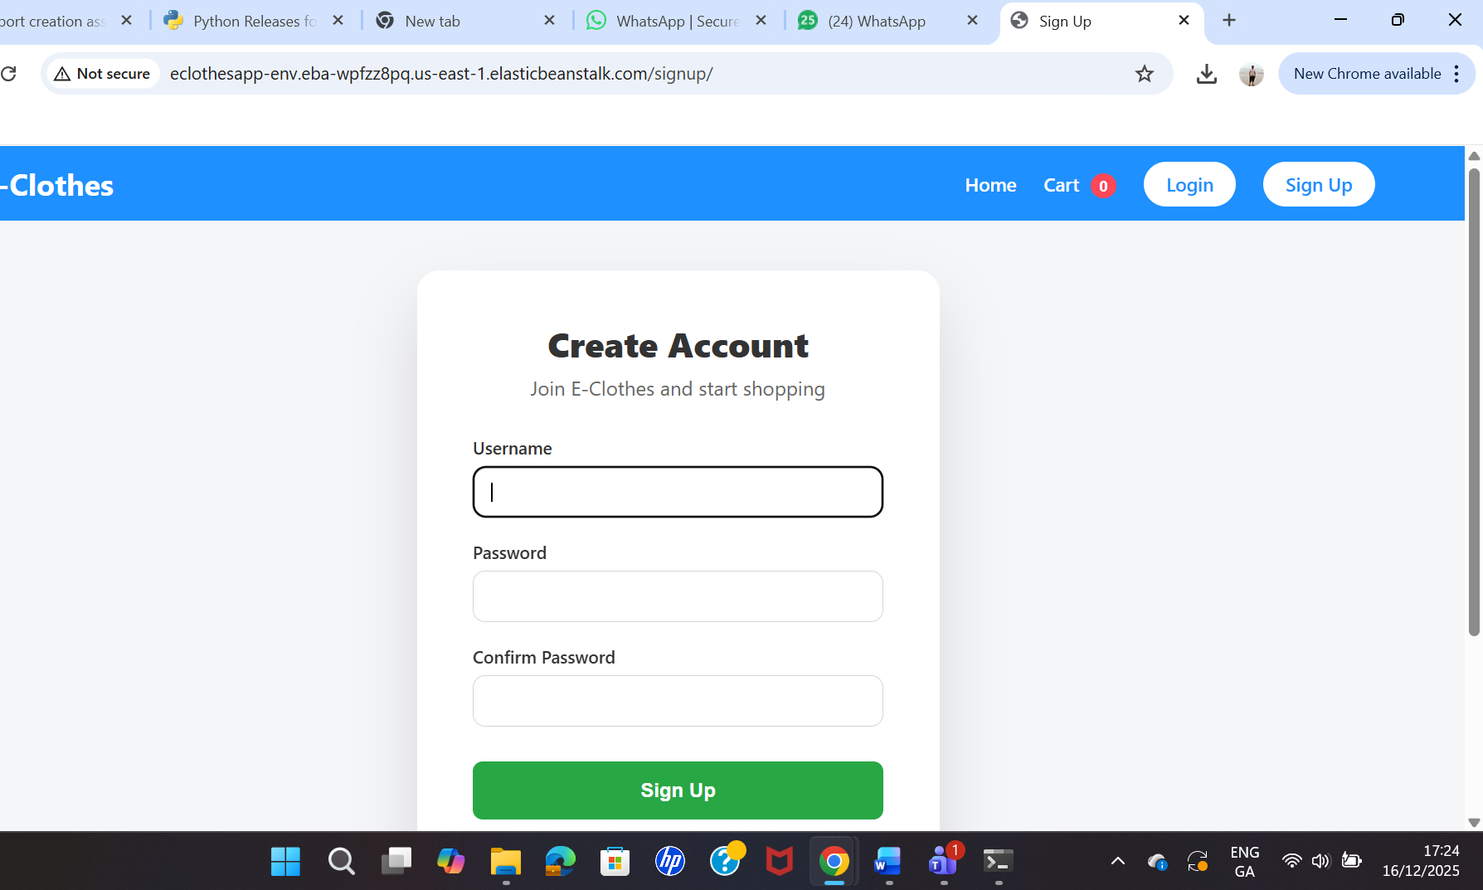
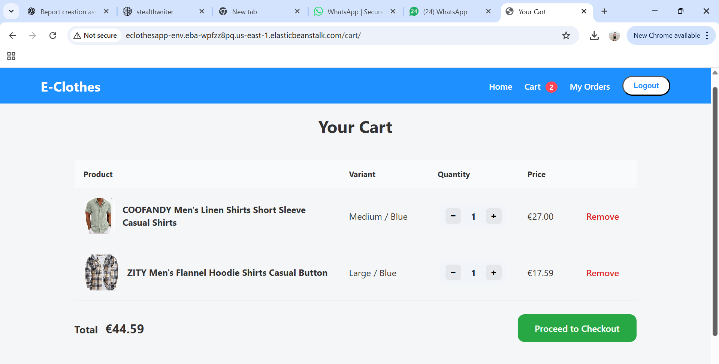

link to run website
http://eclothesapp-env.eba-wpfzz8pq.us-east-1.elasticbeanstalk.com/

